Evaluating User Adaptation to an Assisted Reality device: A Comparative Study between Assisted Reality and Traditional Instruction Methods
(paper under construction for EDUCON 2024)
Time spent on the training of the HMT-1 user can be a notorious delay on the use of the device for learning. To test if it is necessary a training on the use of the device for following basic instructions a comparative analysis was conducted with three groups of participants, each subjected to different instructional methodologies. The experiment revolved around the HMT-1, contrasted against conventional printed instructions. A pre-task questionnaire assessed the participants' demographics and their self-efficacy in general engineering, experimentation, and tinkering, aiming to contextualize their background in relation to the tasks at hand.

Methodology
The experiment was performed in sets of 3 participants to get a reasonably comparable population. Those participants are randomly assigned to a different letter, A, B or C. They all answer the pre-task survey assigned to their letter and are separated into different areas to work independently. All 3 participants will perform the same task, but A and B follow digitalized instructions while C follows paper instructions:
- Participant A gets the HMT-1 device in its case and follows an e-learning tutorial on the use of the device. Afterwards, there will be a short interview with the researcher where questions about the device can be done and answered. If the researcher perceives any device misuse, it will be corrected.
- Participant B gets the HMT-1 device, in its case, the original quick start guides of the device and access to the internet for extra info. In addition, the participant can research and interact with the device to get used to it.
- Participant C plays the Control Group role. They do not receive the device, but their work is fundamental to have a foundation to build on.
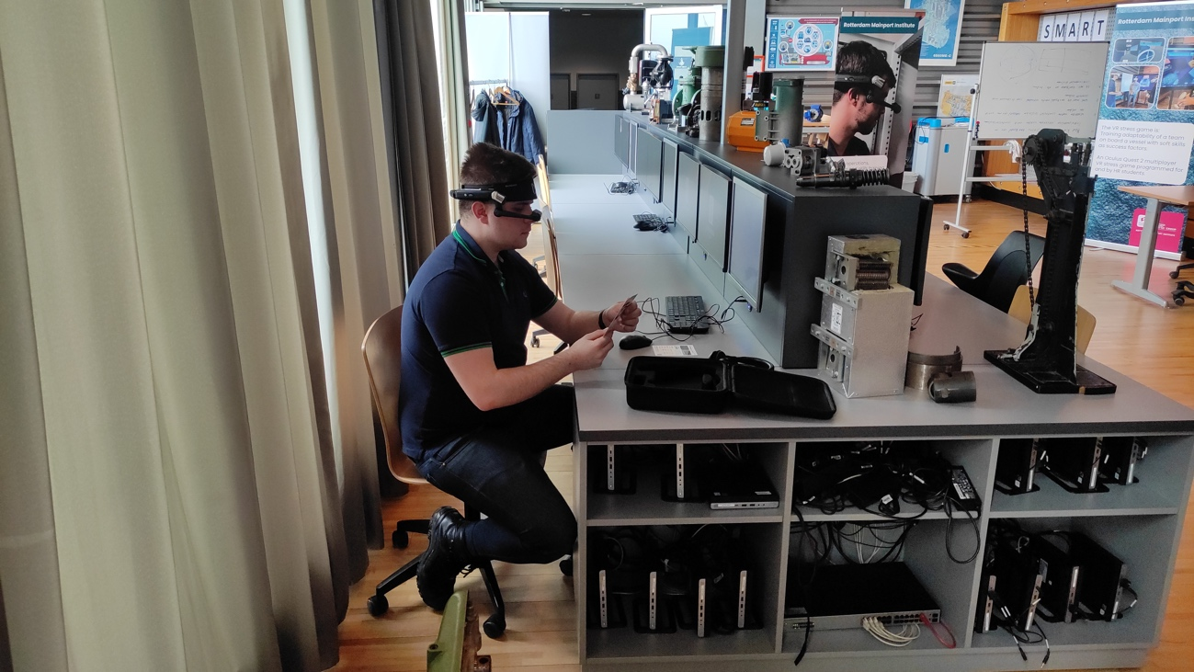
1. Participant B in self-training.

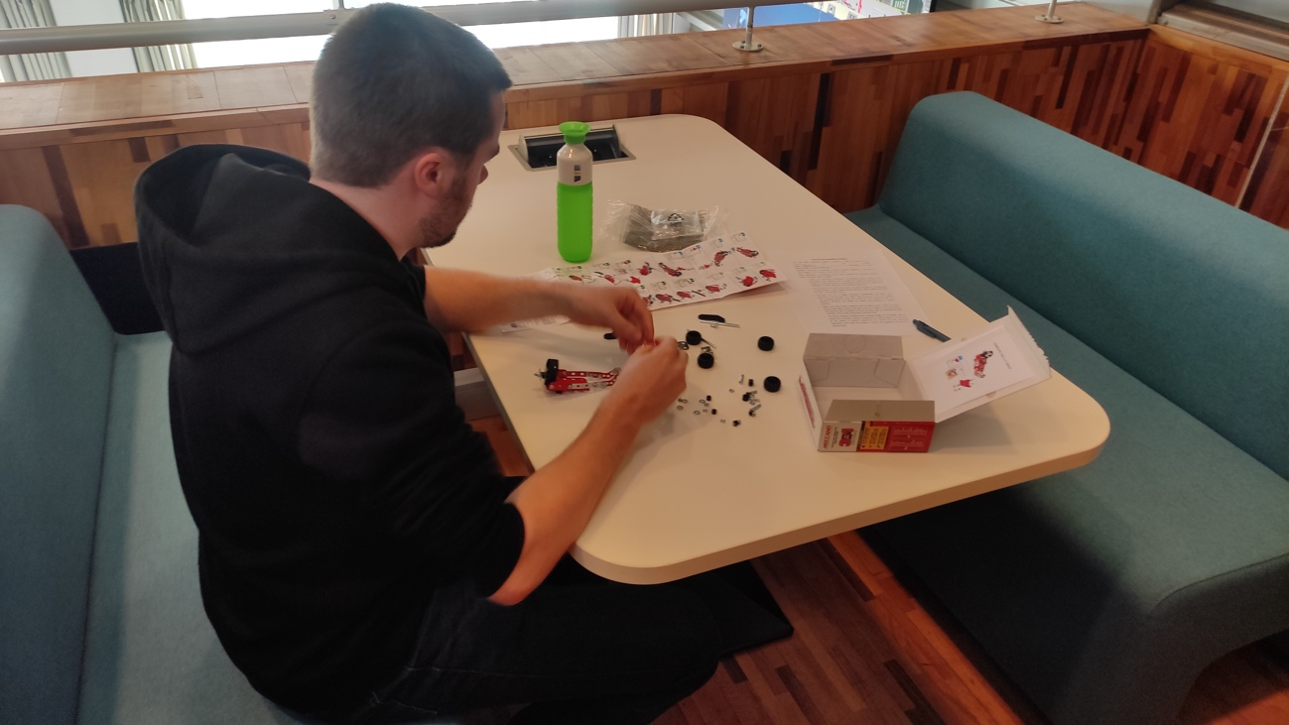
2. Participant C performs the task with paper instructions.
The task can vary but must focus on a simple exercise to follow in a linear workflow. The instructions can be digitalized or printed but must be identical for the three participants when followed with the device or on paper.

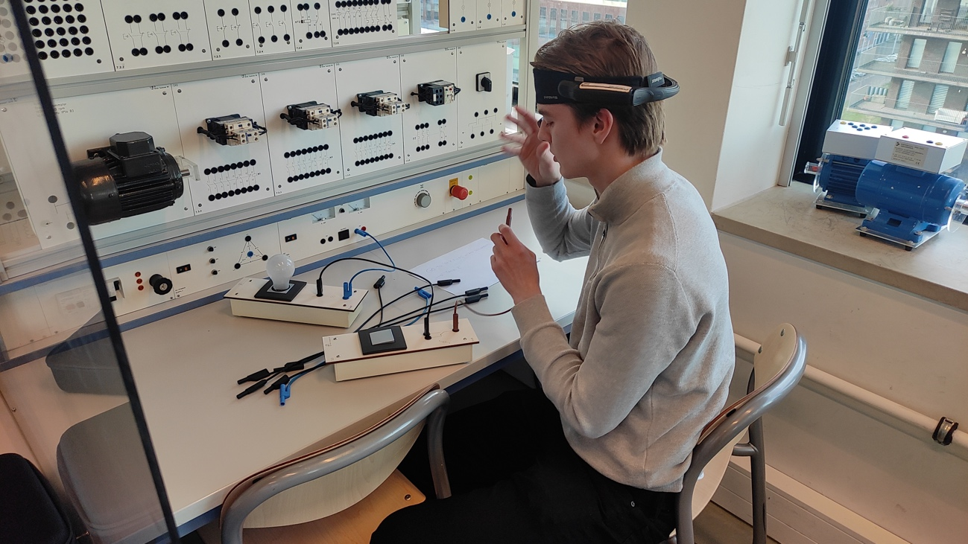
3. Participant A follows digitalized instructions in the electric panel.

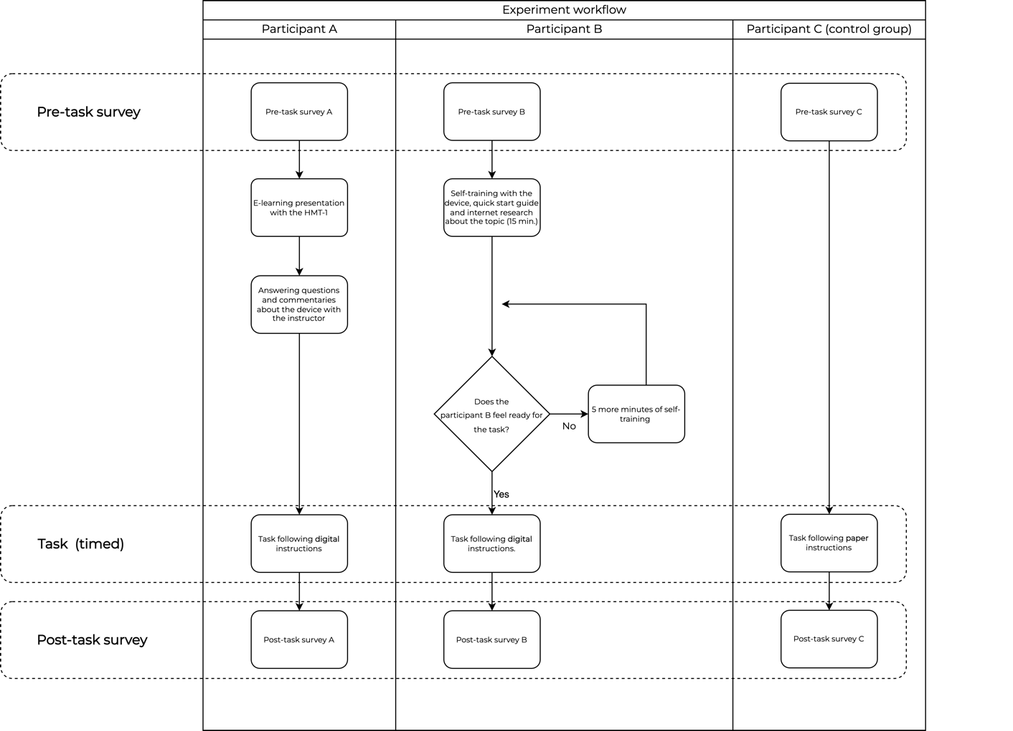
4. Basic scheme of the experiment

Results
The findings indicate a negligible difference in participants' performance irrespective of the instruction method. This observation suggests that engineering students possess an inherent ability to adapt to new technologies, potentially diminishing the need for extensive initial training. However, the study also highlighted certain limitations, including user discomfort and the potential for visual impairments when using such devices, which are critical considerations for educational environments.
Another notable outcome was the difference in task completion times between individuals who used the HMT-1 and those who used traditional instructions, which was noteworthy. This variation suggests that increased work efficiency is not a given just because technology is present.

Implications and conclusion
The adaptability observed among the participants suggests that instructors can integrate such devices more seamlessly into learning scenarios. This finding implies a potential reduction in the time and resources dedicated to introducing new technologies, allowing for a greater focus on their application in practical learning environments. Understanding the challenges users face can guide the development of more effective instructional designs and preemptively address issues that may arise during task execution.
The research highlights that while integrating technology does not necessarily increase the perceived difficulty of tasks, it does not uniformly enhance task performance. This result underscores the need for a strategic and thoughtful approach to technology integration in engineering education, ensuring that it adds intrinsic value to the learning process.
This study provides significant insights into the dynamics of technological integration in engineering education. It emphasizes the importance of aligning technological advancements with educational goals to optimize learning outcomes. The findings advocate for a more nuanced approach to integrating technology that goes beyond mere adoption and focuses on enhancing the overall quality and efficacy of the educational experience. In conclusion, this research contributes to the ongoing discourse on the role of technology in education, particularly in engineering, and lays the groundwork for future studies in this evolving field.

Aarón Miguel Acevedo Reverón, University of La Laguna

