

Project. RELAR (REmote Learning and examination based on AR)
Grant Agreement n. 2020-1-NL01-KA226-VET-083043
Overview Output 02

Deliverable authors: Thomas Kogias, Dimitris Zissis
Deliverable version: 1.0
Deliverable date: 20-10-2023

Key Outputs
O1T1 - Capture and define requirements for the development of RELAR and architecture design
In this initial phase the partners captured the different requirements of potential users from education and industry who will be interested in the future to use assisted reality software products based on the AR learning experience proposed in O1T5 (called from now on the RELAR app).
Aegean University and the other partners identified different functional and technical requirements that the RELAR app should follow in order to fulfill the needs of the users. Some of these are: Share data FROM endpoint to the HMT-1, sending or uploading various types of files (DOC, PDF, PPT etc.) from one endpoint (e.g. a computer) to the HMT-1, video calling, leverage of QR Codes etc.
An architecture for RELAR applications was also defined having in mind the above mentioned functional and technical requirements. Details about the requirements and the architecture are specified in the document “Guidelines for using the HMT-1 in learning environments” (annexed).

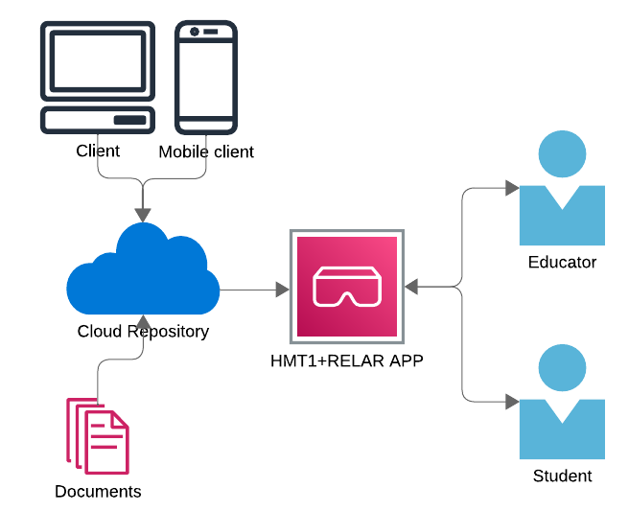
A high level depiction of the overall architecture adopted in the RELAR project to fulfill the user requirements and needs. The architecture adopts a client server model, adapted for the needs of the project. A public google sheet is being used as an easily accessible “cloud repository” where the location of all resources is located. The RELARSCANNER app scans a QR code with the sheet’s unique ID and uses the sheet data to create a list of the resources, present it to the user and then download/open relevant files/apps within the HMT-1. Hence, the users can access and interact with the material through the HMT-1, interacting in an Assisted Reality way in the field. The list can be saved and accessed again without re-scanning the QR code.
O1T2 - Development and collection of interactive + 3D learning content (from involved partners)
The partners identified and aggregated relevant digital learning content that is necessary to build the RELAR app, these being images (jpeg/png), files (pdf), or other digital apps that can improve the students learning experience. All these digital objects were uploaded in the cloud, with the correct access rights in order to ensure these can be find and opened by the RELAR app.
A Google sheet page was chosen as an easily accessible “back end” where all the materials’ URL addresses can be easily stored. The unique ID of the google sheet can be encoded into a QR code that the Relarscanner app can scan in order to scan the sheet. RelarScanner app will then parse the data in the google sheet and automatically create an appropriate list for the user to browse. Upon selection of each item on the list, the relevant file is being accessed, locally saved on the HMT-1, and opened on the device. In the case of ZOOM meeting link or Youtube video, the relevant app fires up.
The user is given the option to save the list locally onto the device so that it can be accessed again without re-scanning the QR code.

O1T3 - Definition of communication protocol
During the project different test cases were done in order to identify the key aspects to be considered when communication takes place between a teacher/instructor and a remote learner using RELAR app.
These can be formulated as follows:
- Confirmation of the communication pre-assumptions
- Training is a requirement
- Good internet connection is a requirement
- Noise cancellation (headphone combination required)
- One message in a sentence and processing & adaptation time
- Some types of display reflection in the glasses (LCD display, Furuno VDR panel) - advice for suppliers
- Uploading a schedule or drawing supports SA
- Real live translation function (nice to have)
- Clear commands/standard phrases list for example (please check)
- Listen first than act
- Ultra wide camera hardware add on (nice to have)
- Explain exactly what you do (pressing a button etc.)
- Focus point of the camera important
- Old patterns of remote assistance should be renewed (use all functionalities)

Partners understood to follow these suggestions when developing and executing the training scenarios from package O2. Some of these suggestions are technical and will be taken into account in the next projects that the consortium will start in order to develop more RELAR apps and related learning content.
The HMT-1 is a hands free device which operates based on voice recognition. Within the context of the project, partners adopted the standard set of voice commands commonly used in HMT-1 applications, while providing a number of their own application specific commands (see RelarScanner documentation below for more specific info). With this approach the RELAR app, created a homogenous environment and continuity with other applications a user would be accustomed to when operating the HMT-1.
The communication model of Remote assistance is depicted in the following graph.
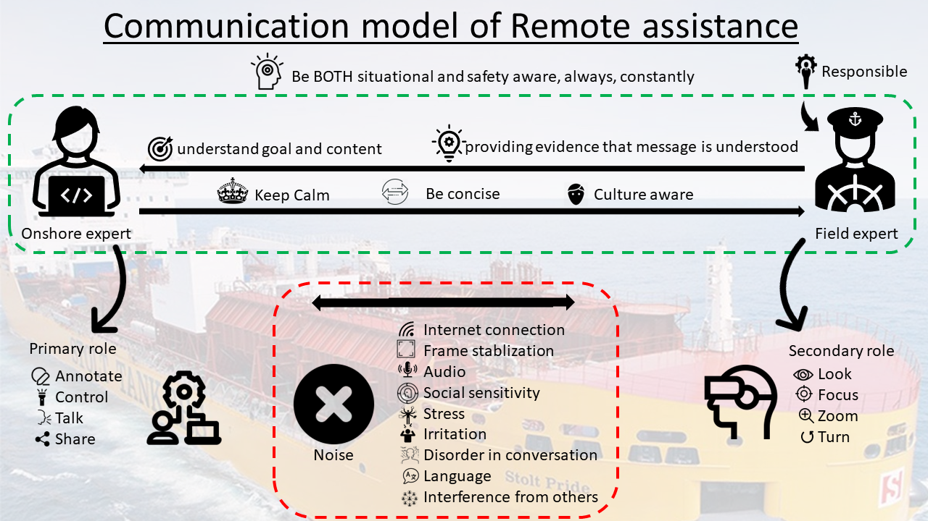

O1T4 - Documentation of objects and development of repository
In this task we developed a software repository (Github) where all the software source code is stored and made publicly accessible. Please follow this link for the source code.
Also, extensive documentation has been created, consisting of both text and video tutorials, which demonstrate how the software can be installed and operated. Please find all relevant documentation here.
Finally, some relevant links to useful files and/or templates follow here:
RelarScanner2 Google sheet template (used as a back end for Relarscanner2 – see documentation for more info):
RelarScanner 2 APK File (To install in Android devices such as HMT-1):

O1T5 - Design and development of an AR learning experience, selection of tools and overall framework
After consultation within the consortium, it was decided that a custom app for the HMT-1 would be very beneficial to further facilitate the use of the device in remote training scenarios and enhance the AR learning experience.
We have developed RELARSCANNER, an app that facilitates the use of QR codes as an easy shortcut to a list of PDF files and services such as ZOOM meeting links and Youtube videos. The list can either be saved offline or can be re-generated through a new QR code scan. The list is automatically created from a suitable Google Sheet which acts as a ‘backend’ data repository.
The RELARSCANNER app has been tested in teaching / examination scenarios and allows the user of the HMT-1 device to successfully access a pre-made list of resources while using the device.
The implementation language of choice was Java and our approach followed an Object-Oriented paradigm and standard practices considering software development for Android.
Useful links:
- RelarScanner app source code: https://github.com/belalik/RelarScanner2
- Documentation and tutorials: https://rebrand.ly/relarscanner

O1T6 - Comparison of performances for each tool and evaluate the multi-user interaction through augmenting the human interaction with different groups
In this task we evaluated the performances when using more traditional learning and learning using HMT-1.
A comparative analysis has been conducted under the lead of Aegean University.
During the 2020-2021 academic year, a group of teachers and researchers of STC Group were able to evaluate the RELAR solution. The pilot use case involved successfully exchanging maritime technical knowledge and information between an operator and a remote expert using the AR device in the field. Specifically, in the first use case scenario, the student trains and is examined remotely by giving instructions to the operator (teacher) in the engine room. The teacher carries out these instructions as an actor, whereby the student can watch using Microsoft Teams on their own devices (home computers, laptops, etc.) and a second teacher gives instructions to the teacher or assesses Following this, the students were in turns located in the engine room and wearing HMT-1 with the teacher using a laptop outside the engine room (in a control room). The teacher coached the student remotely by giving instructions (speech and annotations), and guiding him/her execute a specific task in the engine room.
Additionally, the possibility to perform practical exams remotely with AR was evaluated during the pilot. The proposed setting was connecting the student using a laptop from home to give instructions to the teacher in the engine room in order to solve a technical problem. The student must direct the teacher step by step in how to solve the problem. Controlling is done by speech using the suggested communication protocol. The teacher can intentionally put the student on the wrong track to test and evaluate his knowledge and skills. During the exam, the teacher can evaluate the knowledge and skills of the student by assessing the quality of the instructions given. A second teacher is present in the setting as a second evaluator. The exam must be completed in a predefined time frame.
After the students had completed the course, an online survey was conducted. The main purpose of the survey was to examine whether such AR tools and specifically RELAR contributed positively to the learning process.
Thus the research question was to compare normal learning with learning through HMT-1, while evaluating the interaction and various other parameters. The survey used several questions and responses were evaluated with the aid of the Likert scale. The statements used in the survey were selected based on the relevant literature, related to measuring the effectiveness of such systems in education. The main aim is to qualitatively and quantitatively measure the effect such systems have on the user’s learning ability.
The survey was created using the EU-Survey application and was distributed to the students electronically. The results were anonymous and participation was voluntary. The first part of the survey focused on demographic information, while the second part was focused on the main research hypothesis. Control questions were included. The average time required to fill out the complete survey was 5 minutes.
A total of eight (8) out of the 28 students in the class responded to the survey. The majority of these responded that they felt comfortable with the technology. A small percentage of these students (25% or 2 students) own a VR/AR device, less than 40% (3) had used a similar device in the past, while it was the first time all the students had ever used the specific AR device. Overall, although a small number of the total number of students participated, the main research hypothesis can be confirmed, as 75% of the students followed the process successfully and responded that they preferred it than being in the physical engine room. See Table 1 below.
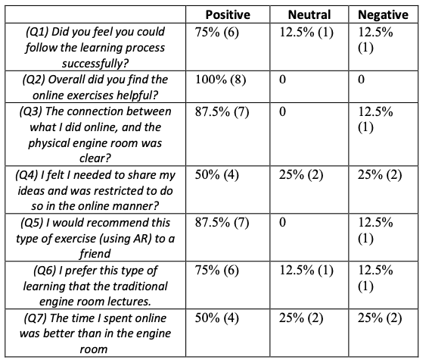
One of the main conclusions we could draw after executing all the above-mentioned pilots is that students embraced this method of learning very quickly and with enthusiasm. The majority of students were very positive about using HMT-1 device for familiarization with technical equipment and procedures and perceived the experience of watching the lesson from home as very convenient. It is interesting that in the open response questions one of the students responded that, “although participating remotely you can actually feel the physical parts of the engine”.
Note. A comparative analysis has been conducted under the lead of University of La Laguna as well. Please see the annexes.

